**G'day everyone,**

My name is Vikas Singh and I am an open-source enthusiast. I volunteered for [**Write the Docs Australia India 2020 Conference**](https://www.youtube.com/playlist?list=PLZAeFn6dfHpl2E5JhVd34llZD4a4oAeCo) on 3rd and 4th December. Overall it was an enriching experience for me and I am delighted to share my key takeaways from it. Before I get into details, *I want to give a huge shoutout to Write the Docs Community for making this conference possible. A huge thanks to all the Sponsors, organizers, speakers, volunteers, and everyone who is a part of it.*

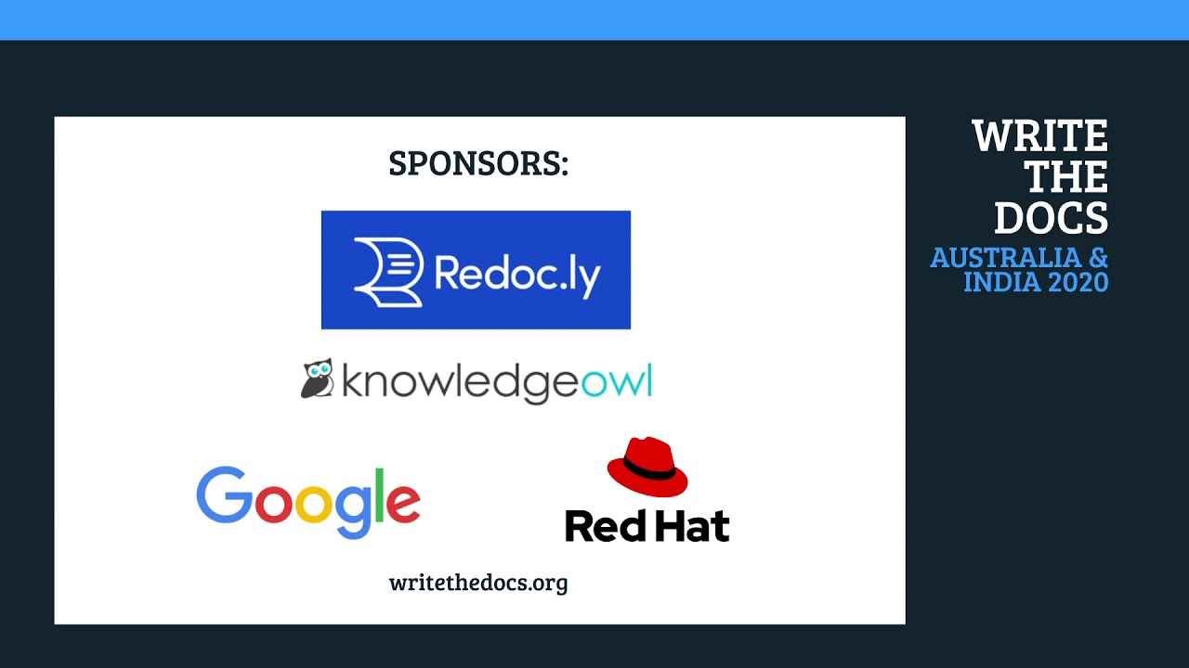

I have not attended any International Conferences yet. So this was my first International Conference experience. It was a great opportunity to connect with new people, learn cool stuff about open source and technical writing, and help the organizers for the smooth facilitation of the conference. As there was a difference of 5:30 hours between the AEDT(Australian Eastern Daylight Time) and IST (India Standard Time), we all have to adjust according to the AED Time.

**So these are the key takeaways that I am delighted to share.**

**1. IMPORTANCE OF PRE-RECORDED SESSIONS**

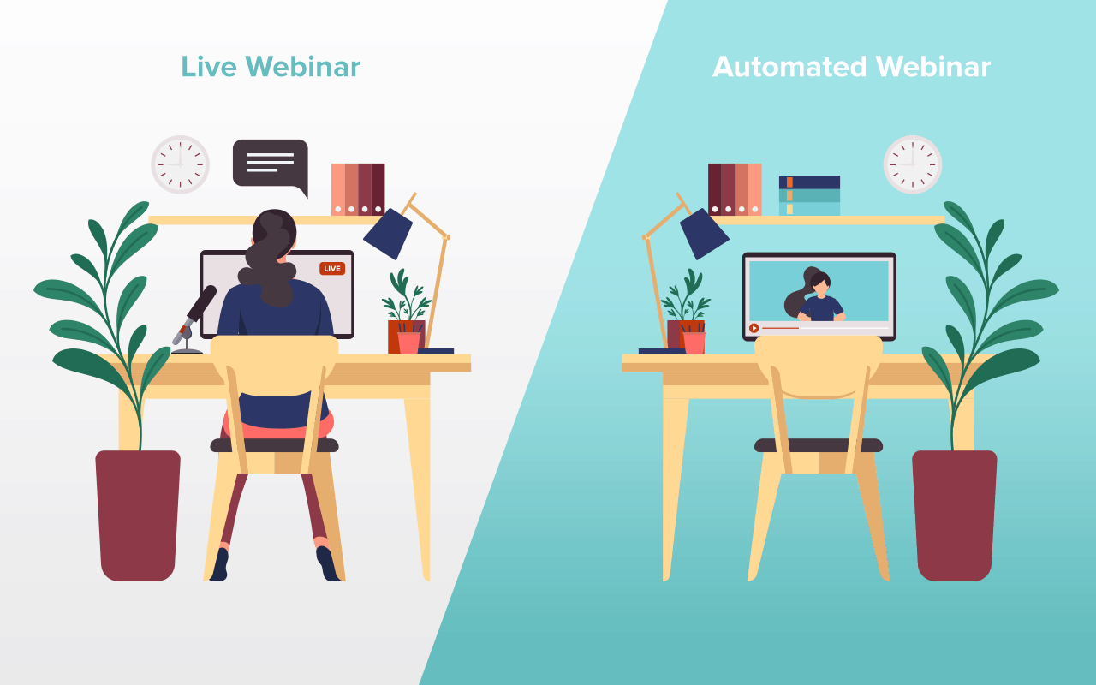

I learned how large conferences are made more presentable with the help of Pre-recorded sessions. These sessions are always beneficial to have. The speakers would not be having any kind of technical glitches at the time of the conference.

We can add cool graphics, amazing transitions, and edits.The best part is that we can control the start and the end timings of the conference. These sessions always provide a better audience experience. Therefore, having these pre-recorded sessions is always a bonus point.On the same note, all the WTD stage sessions were pre-recorded. This made the sessions more smooth.

**2. UNCONFERENCE SESSIONS AND THE LIGHTNING TALKS**

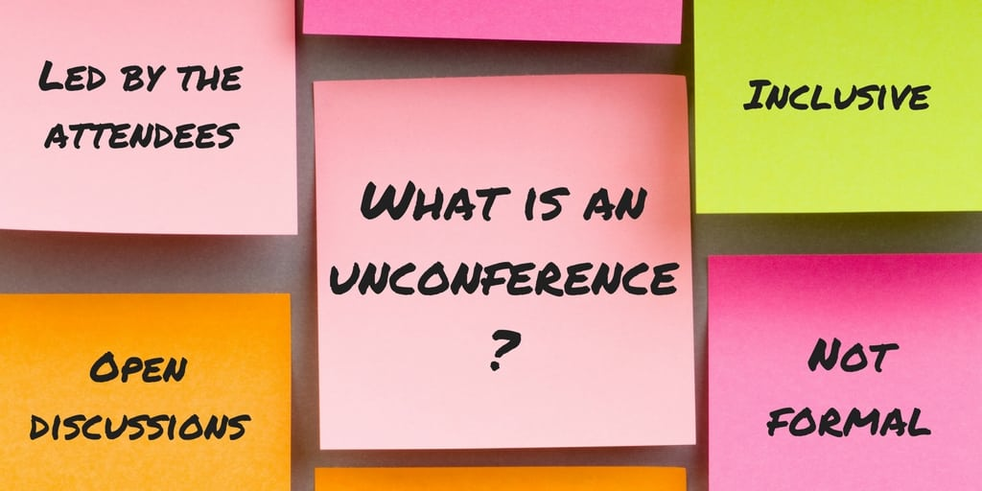

**Unconference Sessions** are informal conversations that provide all participants with an opportunity to exchange informal talks and connect with a lot of people. The participants are allotted time and space to exchange informal talks. The best part is that you can make a lot of connections and friends here.

**Lightning Talks** are short duration talks. These can be formal and informal talks that last for up to a few minutes. As the name lightning suggests, these talks are as fast as the speed of the lightning.

In this one, the lightning talks were of 5 minutes. If you like to give extempore talks and want to prepare yourself for public talks, you should give it a try. The speakers can choose any topic and give a short 5-minute talk. In addition to this, it is a fabulous chance to grow your network with the other speakers and the audience as well.

**3. WONDERFUL SKETCH-NOTES**

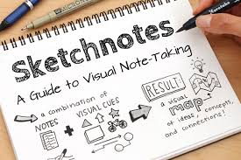

The sketch notes for all the stage sessions were prepared by **Linette Voller**. She is a Design Manager at Atlassian. All the sketch notes were so awesome that I cannot describe them in my words. The appreciations were so much which made her give a lightning talk on “5 steps towards making Sketchnotes”.

[**Check the Wonderful Sketchnotes here!**](https://drive.google.com/drive/folders/10h8EguUikzaTqRRRScflxRdSBDD1G3Hq?usp=sharing)

**4. KUBEFLOW AND CONTRIBUTION TO KUBEFLOW DOCS**



I learned that Kubeflow is an Open Source Machine Learning Platform that eases out the deployment of ML workflows on Kubernetes in a simple, portable, and scalable method.

So if you are a Python or Machine Learning Enthusiast, you can try contributing to Kubeflow. The best way to get started is by reading its official documentation. So it was another cool thing which I learned about at this conference.

[**KubeFlow Docs**](https://www.kubeflow.org/docs/)

**5. LIVE Q&A SESSIONS**

As I told you about the benefits of pre-recorded sessions. But without live Q&A sessions, all our pre-recorded sessions are incomplete. The live interaction of the audience and the speakers is best reflected in the live question-answer sessions.

Here we can get all our questions answered in real-time. So, I learned that Q&A sessions are the must-have parts of any conference.

**Ending Notes**

Participating in this conference was a fantastic experience for me. And I am looking forward to taking part in more such conferences and talks. Once again, thank you to [**WRITE THE DOCS**](https://www.writethedocs.org/) Community and everyone who made this conference possible..

**This is Vikas Singh, signing off :)**